KOLKATA,BHUBANESHWAR & BHOPALPUR
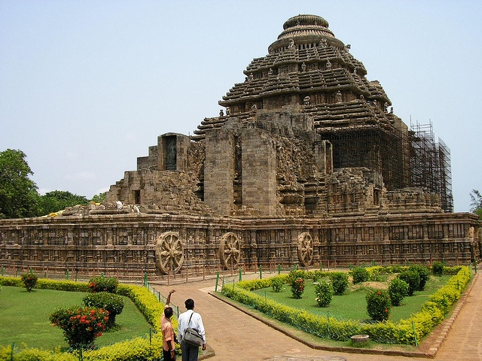

ITINERARY PUBLISHED:
17 JUN’26 | DAY 01 | DELHI – BHUBANESHWAR (6E 2296 : 0920HRS / 1130HRS) – PURI (70KMS, 01 HRS DRIVE)
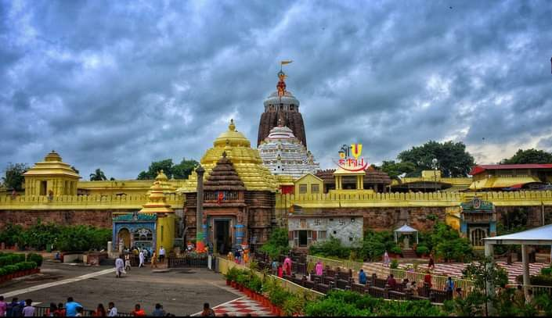
Meeting and assistance upon arrival at Bhubaneshwar Airport and drive to Puri. Upon arrival, check in at hotel in Puri.

Later in the afternoon visit World famous temple Jagannath Temple, is a Hindu temple dedicated to Jagannath, a form of Vishnu. The temple is renowned for its annual Ratha Yatra, chariot festival, which honours the three deities - Jagannath, Balabhadra and Subhadra. During the festival, the three principal deities are pulled on large and elaborately decorated raths, or temple cars. The worship is performed by the Bhil Sabar tribal priests, as well as priests of other communities in the temple. Unlike the stone or metal icons found in most Hindu temples, the image of Jagannath is carved from margosa wood and is ceremoniously replaced every 12 or 19 years with an identical replica, with an elaborate month long ceremony called nabakalebar. The temple is one of the Char Dham pilgrimage sites

Dinner overnight stay in Puri

18 JUN’26 | DAY 02: | PURI – KONARK – PURI (38KMS, 01HRS DRIVE ONE WAY)
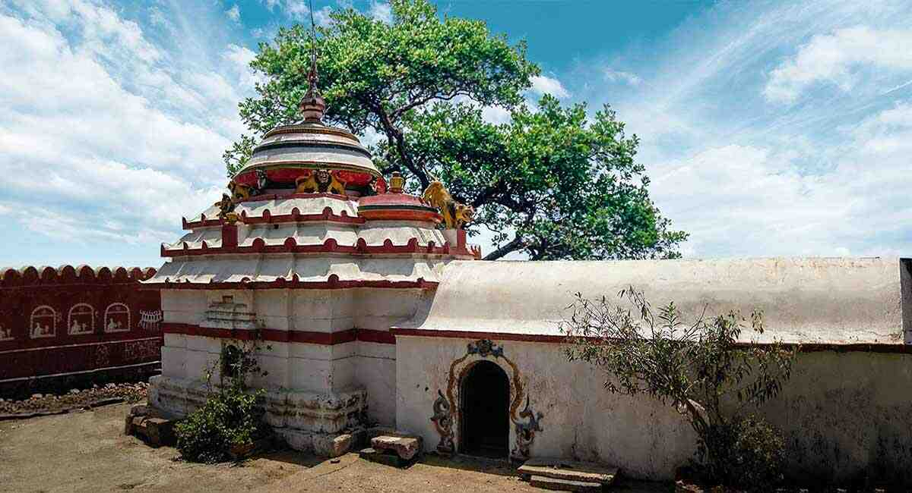
Morning after breakfast drive to Konark enroot visting Ramchandi Temple: A legend regarding the deity is popular among the locals. Kalapahad, the rebel Hindu Brahmin youth who got converted to Islam, vowed to destroy all the temples of Hindu worship during the 17th century. After destroying the Sun temple, Kalapahad approached Ramachandi temple to destroy it. Then Goddess Ramachandi dressed as a Maluni (a maid servant) asked Kalapahad to wait at the door till she brings water from the river for the Goddess. Kalapahad anxiously waited for a long time to get some cold water. When it was too late and the Maluni did not return he was exhausted and entered inside the temple and found the throne empty. Then he thought the Maluni took away the deity with her and with anger he followed the Maluni. When he reached the bank of the Kushabhadra river he found the goddess Ramachandi floating in the middle of the river. At that time the river was outpouring, so he came back without being able to reach the middle of the river. Then Goddess Ramachandi came in dream of a Panda (priest) and told him to build a temple on the bank of the Kushabhadra river. This place is now known as Ramachandi. Throughout the year many visitors come here to get the blessing of Goddess Ramachandi and to enjoy the scenery of river Kushabhadra and Bay of Bengal.

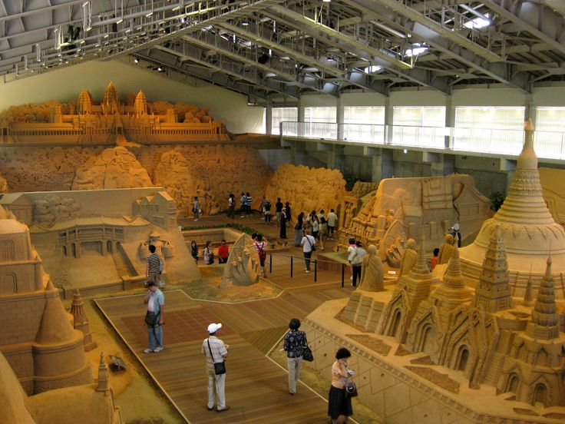
Continue drive to Konark and visit Sudams Sand Art Museum: A young and enthusiastic sand Artist who has crossed several milestones in the field of Sand Art is none other than International acclaimed Sand Artist Sudam Pradhan. He was born from the womb of smt Manju Pradhan who is a house wife. His father Prahallad Pradhan is a farmer. From the very tender age he was attracted towards Sand Art. To materialize his dream he started tiny Sand Arts at the river bed of Jeera close to his village. When he was going to take bath with his mother to jeera he was making sand art at the river bed. He was sucking bliss by creating and destroying idols made by sand. During that time he was given applause from the visitors who were enjoying his sand art. That inspiration created inflammation in his mind and he dreamed to be reached at the pinnacle of Sand Art. Even he dreamed how his sand art can be displayed in the foreign countries. So he left Baragarh, his home city and landed at the holy city Puri in the year 2004. he started work at the Golden Beach where he received a wide spread commendation from the scores of tourists. This dynamic artist was confined to endorse his talent within the bracket of State Territory till 2005. However, his passion broke the barricade and he marched to showcase his talent in places out of the State border mid 2005 he went to Youth festival Kerala, youth exchange programme Goa, sand art summer camp Goa, international film festival Delhi, Festival of Westbangel ,Asha , chenni, shree shree ashram Banglore…….Etc People gave him colossal applause for his intricate work in Sand Art.

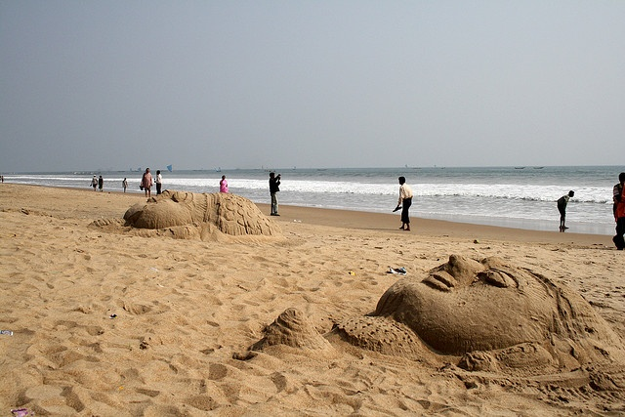
Chandrabagha Beach: According to another ancient narrative reference, Chandrabhag, the daughter of a sage, caught the attraction of the Sun God by her magical charm. The God came down to seek her hand in love. Chandrabhaga did not offer herself to the God. Maddened by romantic pangs, the God chased after a frightened Chandrabhaga, who jumped into the river and killed herself, thus succeeding in protecting her chastity. As a mark of tribute to her sacrifice, every year on the 7th day of the full-moon fortnight of Magha month, people from all over the state and outside gather to take a holy dip in the river that is reduced to a shallow pool, to offer their prayers to the Sun God and to enjoy the sunrise.

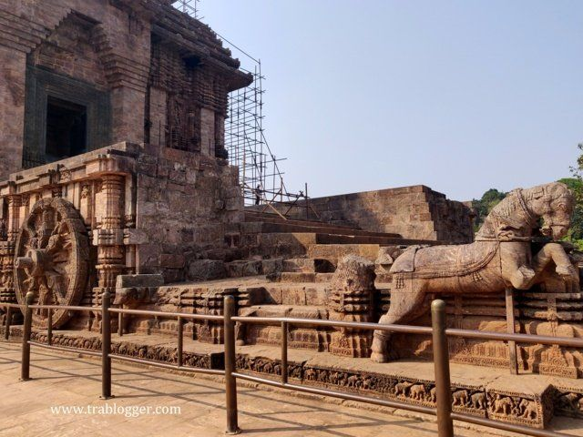
Konark Sun Temple: The Sun Temple at Konârak, located on the eastern shores of the Indian subcontinent, is one of the outstanding examples of temple architecture and art as revealed in its conception, scale and proportion, and in the sublime narrative strength of its sculptural embellishment. It is an outstanding testimony to the 13th-century kingdom of Orissa and a monumental example of the personification of divinity, thus forming an invaluable link in the history of the diffusion of the cult of Surya,the Sun God. In this sense, it is directly and materially linked to Brahmanism and tantricbelief systems. The Sun Temple is the culmination of Kalingan temple architecture, with all its defining elements in complete and perfect form. A masterpiece of creative genius in both conception and realisation, the temple represents a chariot of the Sun God, with twelve pairs of wheels drawn by seven horses evoking its movement across the heavens. It is embellished with sophisticated and refined iconographical depictions of contemporary life and activities.

After visit return back to hotel in Puri.

Dinner & overnight stay Puri

19 JUN’26 | DAY 03: | PURI – BHUBANESHWAR (67KMS, 01HRS DRIVE)
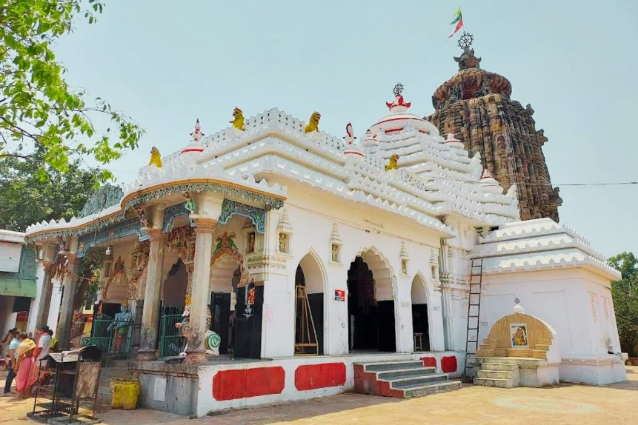
Morning after breakfast drive to to Bhubaneshwar enroot visiting Sakshigopal Temple: It is said that a poor young man of the village, later named Sakshigopala, fell in love with the daughter of the village headman. However, being of a higher economic status, the headman opposed marriage between this young man and his daughter. The villagers, including the headman and the young man, went on a pilgrimage to Vrindavan. The village headman fell ill and was abandoned by fellow villagers. The young man tended to him so well that he soon got well, and, in gratitude, promised his daughter in marriage to the young man. As soon as they returned to the village, the headman went back on his promise, asking the young man to produce a witness in support of his claim.
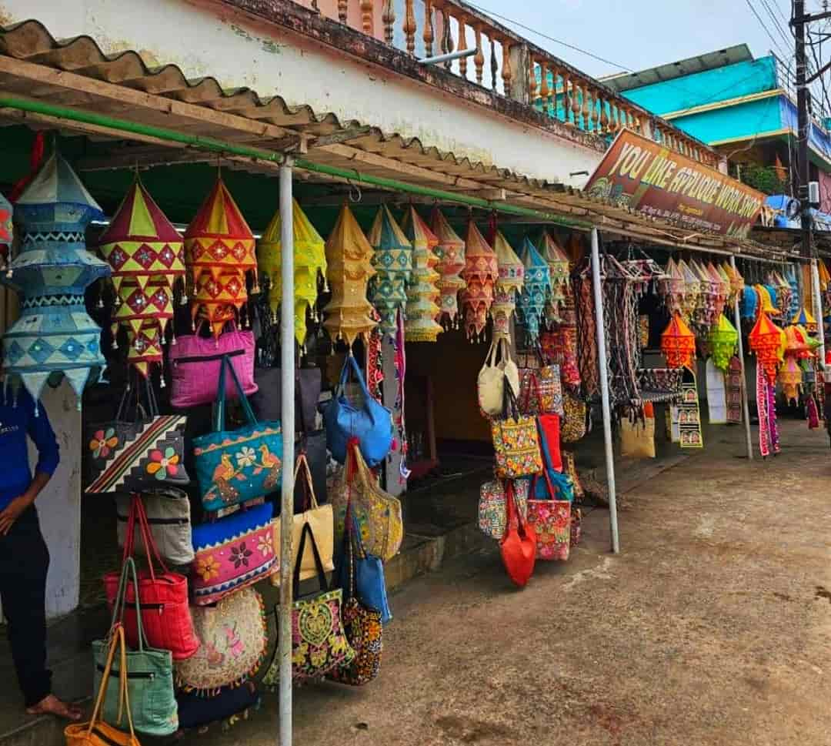
Pipi applique market : The Pipli Applique Market, located in the small town of Pipili (Odisha, India), is a
vibrant hub famous for traditional "Chandua" patchwork. Hundreds of artisan families craft and sell colorful textiles, wall hangings, and ceremonial umbrellas. Prices are highly affordable, ranging from $2 for small souvenirs to $48 for large, elaborate tapestries.
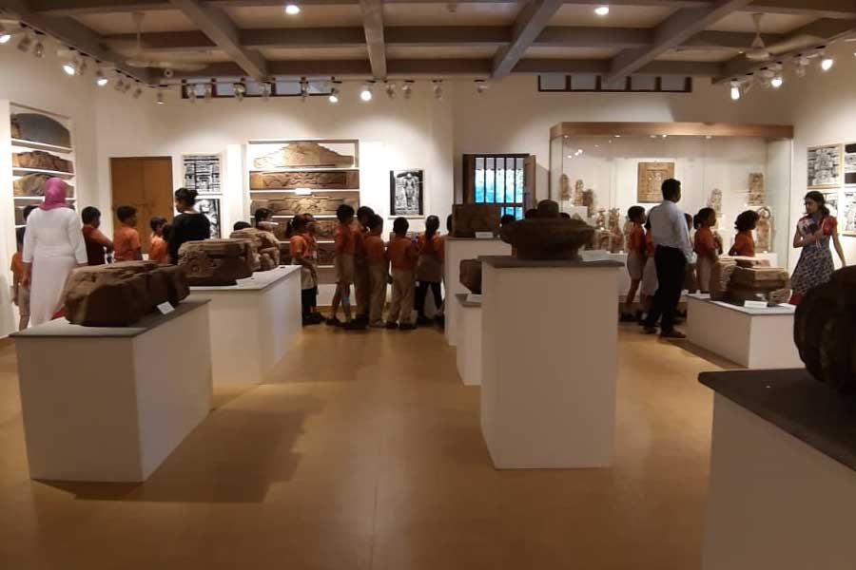
Continue drive to Bhubaneshwar. Upon arrival check in at hotel in Bhubaneshwar. Afternoon visit Kalabhomi craft museum: The museum celebrates the craftsmanship of Odia artisans by putting on display their breath-taking masterpieces. Divided into 2 blocks, the museum has a display area and a live section. The display area focuses on galleries about Handicrafts and Handlooms from around the state while the live section is equipped with an open air theatre as well as separate workshop zones. Kala Bhoomi is built using local raw materials such as the laterite stone which can still be seen in some of the oldest monuments around the state. At Kala Bhoomi we have 10 galleries out of which 9 are open to the public. There are two blocks. The Handicrafts block contains Terracotta, Traditional Paintings, Stone and Wood Carving and Natural Material crafts galleries on the other hand the Handloom block displayed the Pre-Weaving Techniques, Tribal Crafts, The Crafts of Shree Jagannath Culture and Handloom galleries which represents the unique and antique raw materials and equipment as well as variety of Handlooms from across the state.

Dinner & overnight stay in Bhubaneshwar

20 JUN’26 | DAY 04: | BHUBANESHWAR – KOLKATA (6E 6793: 0950HRS / 1050HRS)
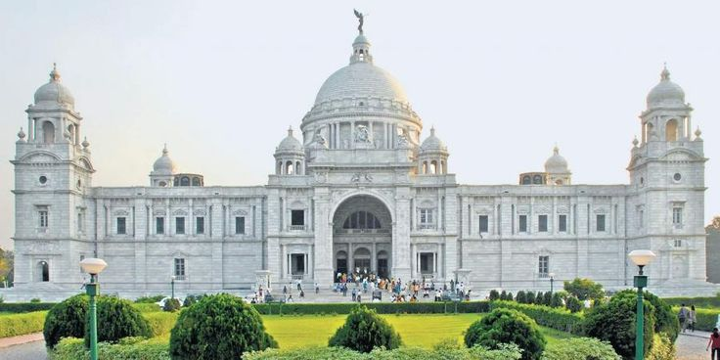
Morning after breakfast drop at Bhubaneshwar airport to board flight for Kolkata. Meeting and assistance upon arrival at Kolkata airport and transfer to hotel in Kolkata. Upon arrival check in at hotel.
Afternoon visit Victoria Memorial: The Victoria Memorial is a large marble monument in the Maidan in Central Kolkata (Calcutta), having its entrance on the Queen's Way. It was built between 1906 and 1921 by the British Raj. It is dedicated to the memory of Queen Victoria, the Empress of India from 1876 to 1901. The work of construction was entrusted to Martin & Co. of Calcutta founded by Rajendranath Mukherjee and Thomas Acquin Martin, and work on the superstructure began in 1910. It is the largest monument to a monarch anywhere in the world. It stands at 26 hectares (64 acres) of gardens and is now a museum under the control of the Ministry of Culture, Government of India. Possessing prominent features of the Indo-Saracenic architecture, it has evolved into one of the most popular attractions in the city.

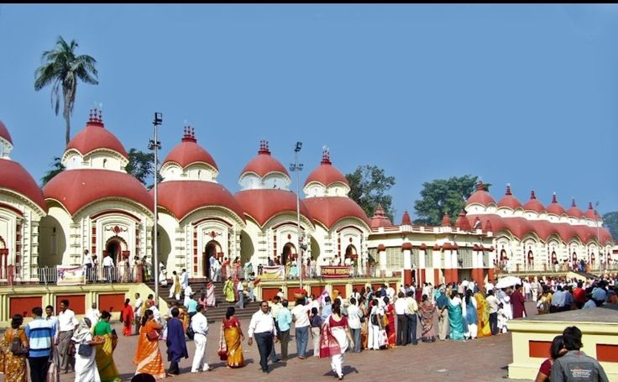
Kalighat Temple, dedicated to the Hindu goddess Kali, one of the 10 Mahavidyas in the Hindu tantric tradition and the supreme deity in the Kalikula worship tradition. The temple is one of the 51 Shakti Pithas in India. According to the Devi Bhagavata Purana, Kalika Purana and Shakti Peetha Stotram, the toes of the right foot of Goddess Sati fell here, after Lord Vishnu's Sudarshan Chakra splintered her body into many parts to calm down Mahadev's rage during his cosmic dance. One of the oldest and most important places of worship in Eastern India, being one of the four Adi Shaktipeeth the temple draws hundreds of thousands of devotees throughout the year, especially on occasions like Kali Puja, New Year, Poila Baisakh, Snana Yatra, Durga Puja and the numerous Amavasyas

Dinner & overnight stay in Kolkata

21 JUN’26 | DAY 05: | KOLKATA
Early morning at 6 am drive to Gangasager. The vehicle will drop at Harwoodpoint. After that cross the river by boat to Kochuberia, from there by private vehicle to Gangasagar: According to regional legend, Kardama made a pact with Vishnu, in which he agreed to undergo the rigours of marital life, on the condition that the deity would incarnate as his son. As agreed, Kapila was born to him as an incarnation of Vishnu, and became a great saint. Kapila's ashram is believed to have been located in this village. One day, King Sagara's sacrificial horse, which was necessary for the performance of his ashvamedha yajna ceremony, disappeared; it had been stolen by Indra. The king sent his 60,000 sons to find the horse, and they found it next to Kapila's ashram, where Indra had hidden it. Mistaking Kapila for the thief, the sons accused the sage of the theft, who in his wrath at the false accusation burned the sons to ash and sent their souls to hell. Later, having compassion for the king's sons, Kapila acceded to the prayers of Sagara's descendants, agreeing to the restoration of the sons, if the goddess Ganga would descend upon the earth to perform the tarpana ritual of mixing the ashes with holy water (niravapanjali) for the sons of Sagara.

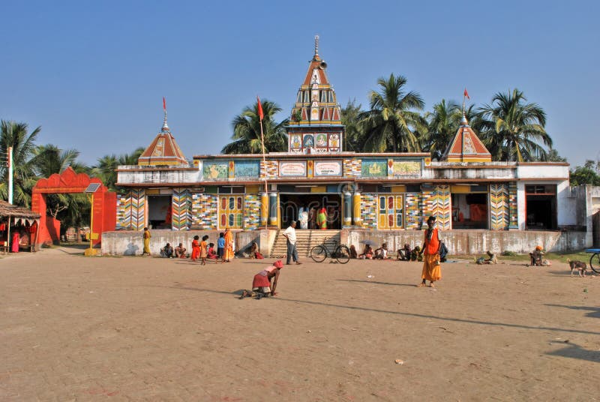
Kapil Muni Aashram: A Gupta era temple existed on this spot. This temple was lost due to coastal erosion. Around the early 19th century, when Warren Hastings had the island cleared of vegetation and the site came under the zamindari of a local Bengali Hindu zamindar from Purba Medinipur called Yaduram who recovered the shrine of Kapilmuni. Then the site came under control of Ramanandi sadhus from Ayodhya. The old temple was made of bamboo which was destroyed in the late 50s or early 60s due to cyclones. The first brick-built temple was built in 1961 for Rs 20,000, and the roof of the temple was made of asbestos. The former Chief Minister Bidhan Chandra Roy contributed Rs 11,000 to the construction of the temple. The construction of the temple was done by "S Chakraborty & Co." The temple was smaller in size than the present temple.

Later drive back to hotel in Kolkata.

Dinner & overnight stay in Kolkata

22 JUN’26 | DAY 06: | DEPART KOLKATA (6E 6516 : 1610HRS / 1835HRS)
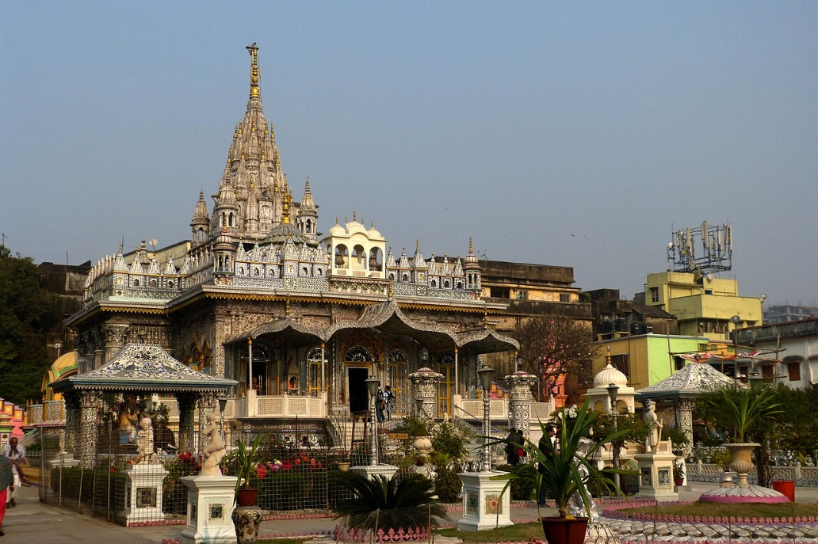
Morning after breakfast check out from the hotel and proceed to visit: Jain Temple: The Parshwanath Jain Temple of Kolkata was built by Ray Badridas Bahadur in 1867. Thousands of people visit this temple annually. Parshwanath is actually a complex of 4 temples. The main shrine is dedicated to Shitalanatha, the tenth tirthankara. The pratishtha, or consecration ceremony, was performed by Sri Kalyansurishwarji Maharaj. Three of the temples are dedicated to tirthankars Shitalanatha, Chandraprabha, and Mahavira. The fourth temple is called the Dadawadi and Kushalji Maharaja temple. Footprints of famous Jain monks Acharya Jinadattasuri (1075-1154 CE) and Acharya Jinkushalsuri (born ca. 1280 CE) are installed here. South of the Shitalanatha temple lies the shrine of Chandraprabha, built by Ganeshlal Kapoorchand Jahar in the year 1895.

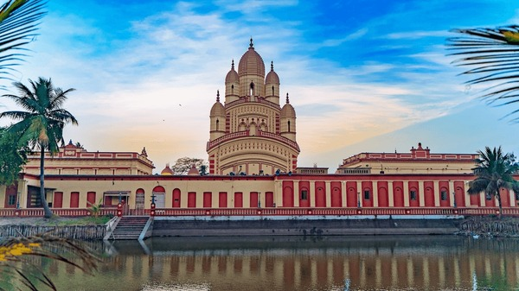
Dakshineshwar Kali Temple: The main temple was inspired by Radhakanta temple in Tollygunge, built by Babu Ramnath Mondal of the Bawali Raj family. The temple compound, apart from the nine-spired main temple, contains a large courtyard surrounding the temple, with rooms along the boundary walls. Along the riverfront, there are twelve shrines dedicated to Shiva, Kali's consort, a temple to Radha–Krishna, a bathing ghat at the river, and a shrine dedicated to Rani Rashmoni. The 'Nahabat', or "music tower," northeast and beyond the last of the Shiva temples, is where Maa Sarada spent a considerable part of her life. Sri Ramakrishna's room is in the northwest corner of the courtyard, with a semicircular verandah facing the river.

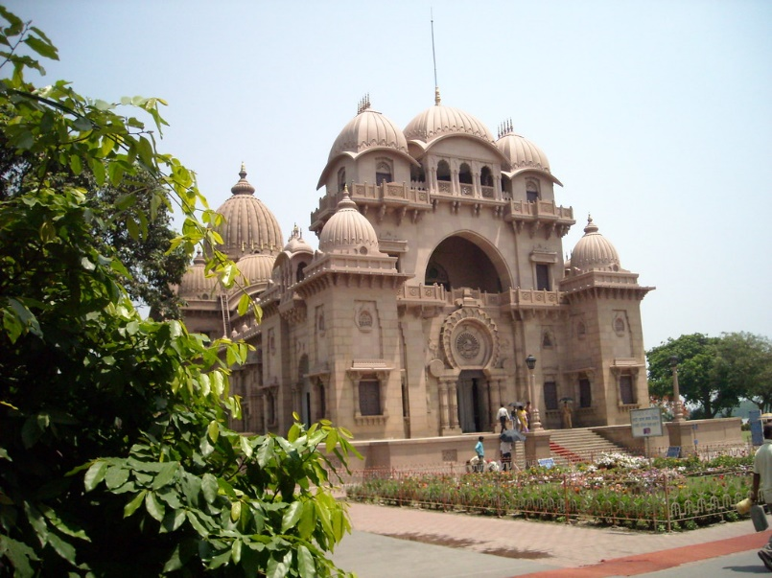
Belur Math: In the beginning of 1897, Swami Vivekananda arrived at Baranagar, Calcutta with his small group of Western disciples. Two monasteries were founded by him, one at Belur, which became the headquarters of Ramakrishna Mission and the other at Mayavati on the Himalayas, in Champawat District, Uttrakhand, called the Advaita Ashrama. These monasteries were meant to receive and train young men who would eventually become sannyasis (religious ascetic) of the Ramakrishna Mission, and to give them a training for their work. The same year the philanthropic activity was started and relief of the famine was carried out.

Later drive to Kolkata airport to board flight for Delhi.

END OF THE SERVICES

TOUR COST:
UNIT | COST PER PERSON
Cost for 10 pax based on 3 star hotels | INR 22400 per person
Supplement for Urbania in Orissa | INR 1900 per person
Supplement for English speaking guide on day 2 & day 03 | INR 8925
Supplement for English speaking guide for day 4,5 and 6 | INR 16275

Air:
Date | Sector | Flight | Timing | Cost
17 Jun’26 | Delhi / Bhubaneshwar | 6E 2296 | 0920 / 1130 Hrs | INR 10,059 per person
20 Jun’26 | Bhubaneshwar / Kolkata | 6E 6793 | 0950 / 1050 Hrs | INR 5951 per person
22 Jun’26 | Kolkata / Delhi | 6E 6516 | 1610 / 1835 Hrs | INR 8961 per person

CiTY | HOTEL 3 STAR | DATE | NIGHTS
Puri | Hotel SKS Beach Resort or similar | 17 – 19 June’26 | 02 Night
Bhubaneshwar | Hotel Swoti Grand or similar | 19 – 20 June’26 | 01 Night
Kolkata | Siamton Inn or similar | 20 – 22 June’26 | 02 Night
Total number of nights |  |  | 05 Night

Our prices include:

Price per person in a Double room.

Bed and breakfast basis as per program
- Transfers & sightseeing by AC 17-seater Tempo Traveller (Odisha part)
- Transfers & sightseeing by Ac 17-seater Urbania (Kolkata part)

02 night in Puri with half board basis.

01 night in Bhubaneshwar with half board basis

02 night in Kolkata with half board basis.

Government tax.

Our prices do not include:

Entrance fees to monuments

Services of English speaking guide

Tips for guides (at the client's discretion).

Travel and cancellation insurance (optional).

Beverages.

Any services not mentioned as included, including personal extras such as telephone calls, laundry

service, etc.

